Petrol Station Locator

User Manual.

10/13/2012

**Author**

The Fighting Mongooses

**Disclaimer:**

The user manual carries work as part of an academic project only and is intended only for Scott Ashwin, a Lecturer at University of Canberra. If you are not the intended recipient you are notified that disclosing, copying, distributing or taking any action in reliance on the contents of this information is strictly prohibited.

­

# Table of Contents

Contents

Table of Contents 3

List of illustrations 4

Introduction 5

Aims and Objectives 5

Scope 5

Audiences 5

Internet Browsers 5

User Manual 5

Access a Website 6

Home Page 6

Services Tab 7

Directions Tab 9

# List of illustrations

Figure 1: Allow Current Location 6

Figure 2 : Home Page 7

Figure 3: Services 9

Figure 4: Directions 9

Figure 5: Direction Search from Example 10

# Introduction

This document carries user documentation for the website Petrol Station Locator.

# Aims and Objectives

The primary goal of this document is to provide an easy and understandable for the users of the petrol station locator website to use the website. And this goal is accomplished by outlining the main objectives of the carried out in the manual.

1. To help the users to understand the website.
2. To help the user understand the provided features.
3. To help the user to make a custom search.
4. To help the user in understanding the website screens.

# Scope

The documentation is indented to provide information of a desktop version of the petrol station locator website.

**Note:**This user manual only applies to desktop computers or laptops and doesn’t provide information on usage of the website on mobile or other handheld devices.

# Audiences

Below are the audience types for whom this user manual created.

* All Vehicle drivers in Australia
* General Public of Australia.

# Internet Browsers

A modern browser is required for the use of this website. Below is the browsers list that this site is compatible with:

* IE 10+
* Google Chrome 22+
* Mozilla FireFox 16+
* Opera 12+
* Safari 6+

# User Manual

## Access a Website

To access a website open a browser and type the address <http://localhost/PetrolStationLocator/> in the address bar.

## Home Page

On access the homepage the browser will ask user to allow current location setting which will pick the user current location using its browser location service as shown in the below figure 1. Clicking on Allow, the a map will be shown on the home page containing icons of petrol station those are within 20 kilometers of user current location as shown in figure 2. Whereas, clicking on Don`t Allow will only show an empty map with no petrol stations icons on it.

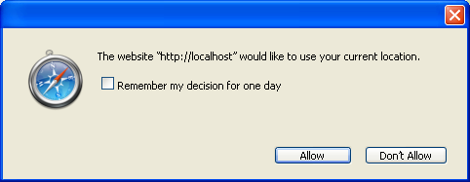

Figure 1: Allow Current Location

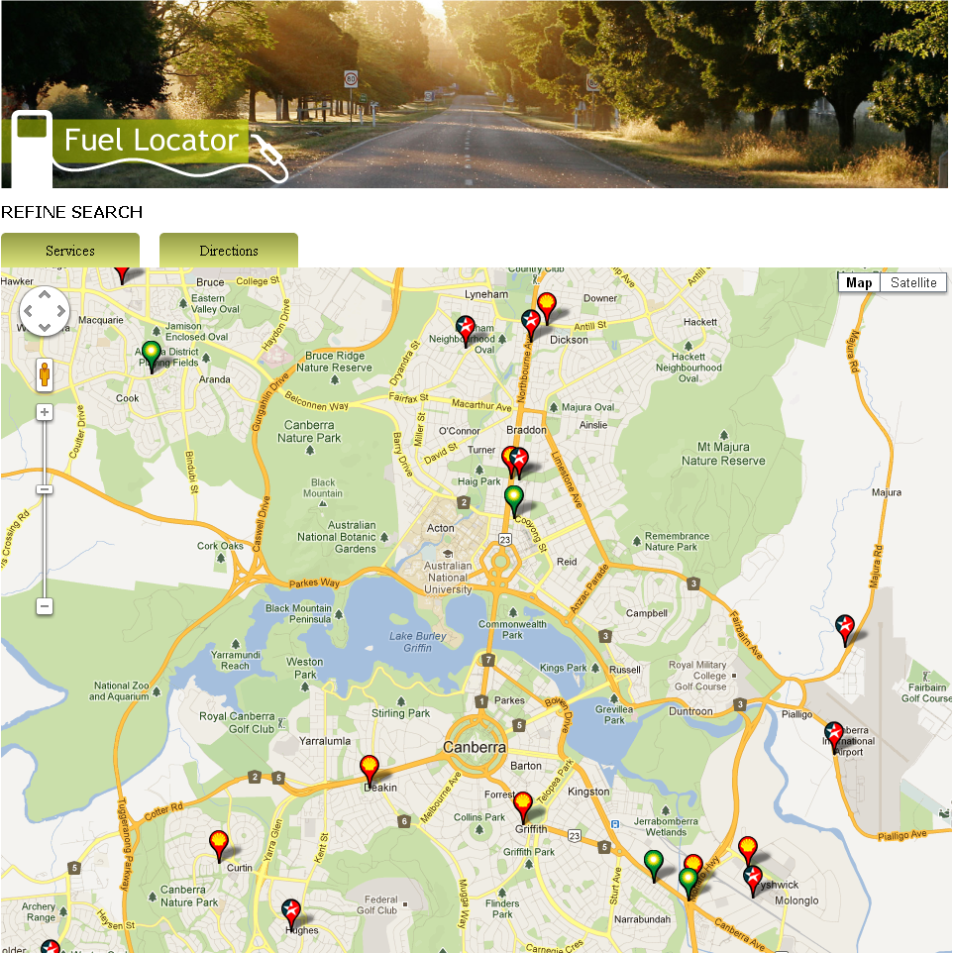

Figure 2 : Home Page

## Services Tab

On the home page services tab is provided to filter the petrol stations on the basis of following services provided at the petrol stations:

* Company
  + All
  + Caltex
  + BP
  + Shell
  + Mobil
  + Fuel Type
* Fuel Types
  + All
  + Regular UnLeaded
  + 91 Octane
  + 95 Octane
  + 98 Octane
  + E10
  + LPG
  + Diesel
  + Premium Diesel
  + Diesel E10
  + Biodiesel
  + Services
* Services
  + All
  + EFTPOS
  + ATM
  + Workshop
  + 24 Hour
  + Car Wash
  + Toilet
  + Disabled Toilet
  + Restaurant
  + BBQ Gas
  + Truckstop
  + Search

The above filter services are provided as check box items as shown in the figure 3 below:

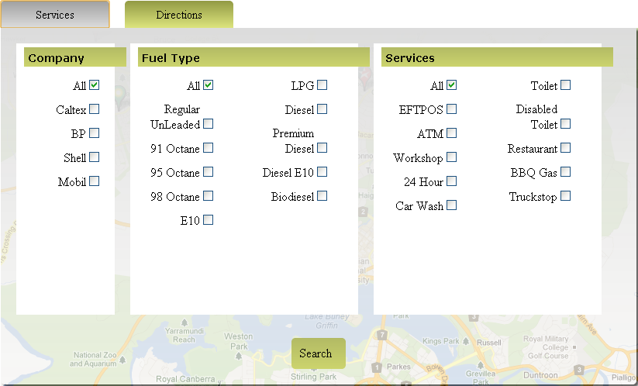

Figure 3: Services

By Default All Options of services types will be checked which means no filter is applied yet. The search button will apply the services search and update the map.

## Directions Tab

The directions tab is used to locate the petrol stations filtered using services tab by getting From and To address from the user and shows only those stations those are near by 4 kilometers along the route path. The user first clicks on the Directions Tab and enters into the Form and To text box to make a direction search as shown in the figure below.

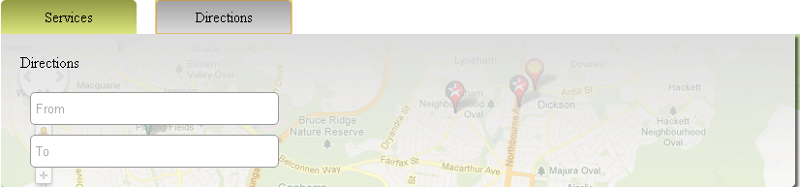

Figure 4: Directions

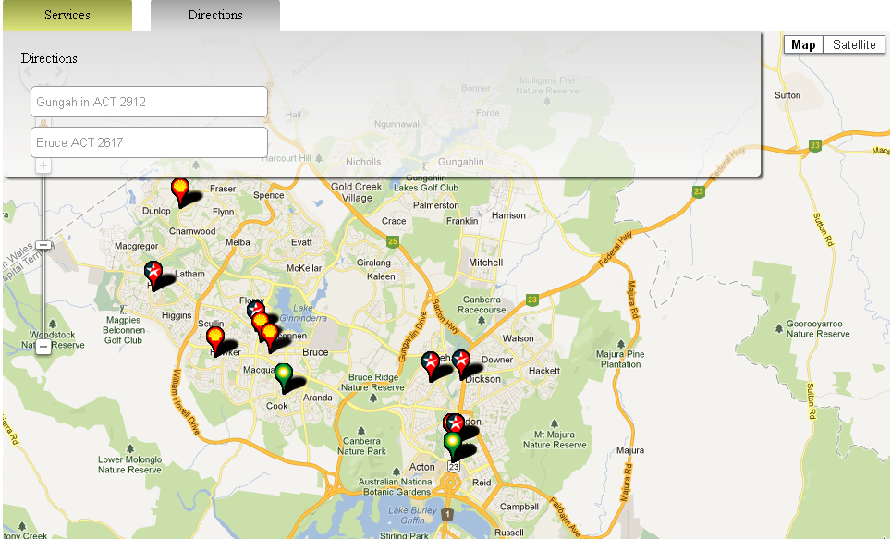

Figure 5: Direction Search from Example